**TITLE: PACMAN GAME**

**Design Tool Used: ARGO UML**

**REVIEW-3** COMPONENTS:

* USECASE DIAGRAM
* CLASS DIAGRAM
* SEQUENCE DIAGRAM
* ACTIVITY DIAGRAM
* DEPLOYMENT DIAGRAM
* COMPONENT DIAGRAM
* STATE CHART DIAGRAM
* COLLABORATION DIAGRAM
* OBJECT DIAGRAM
* CODE
* Graphical User Interface

## Use Case Diagram

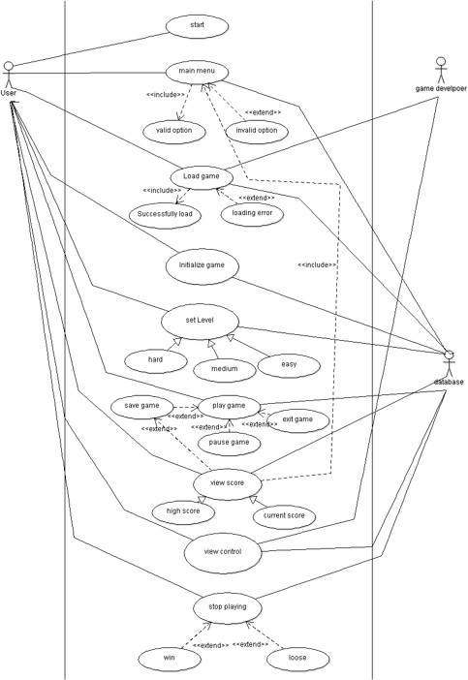

**Class Diagram**

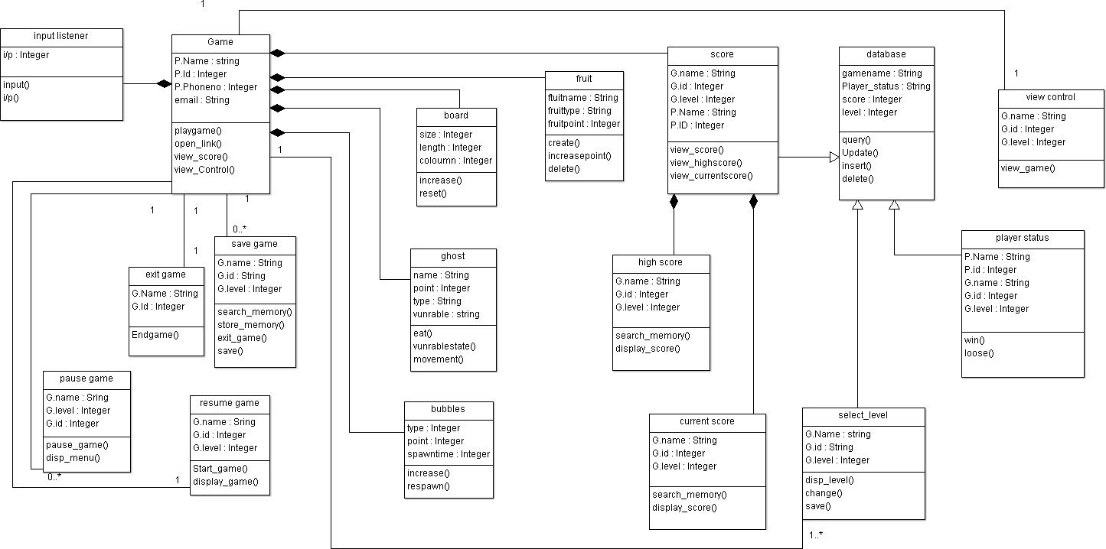

**Activity Diagram**

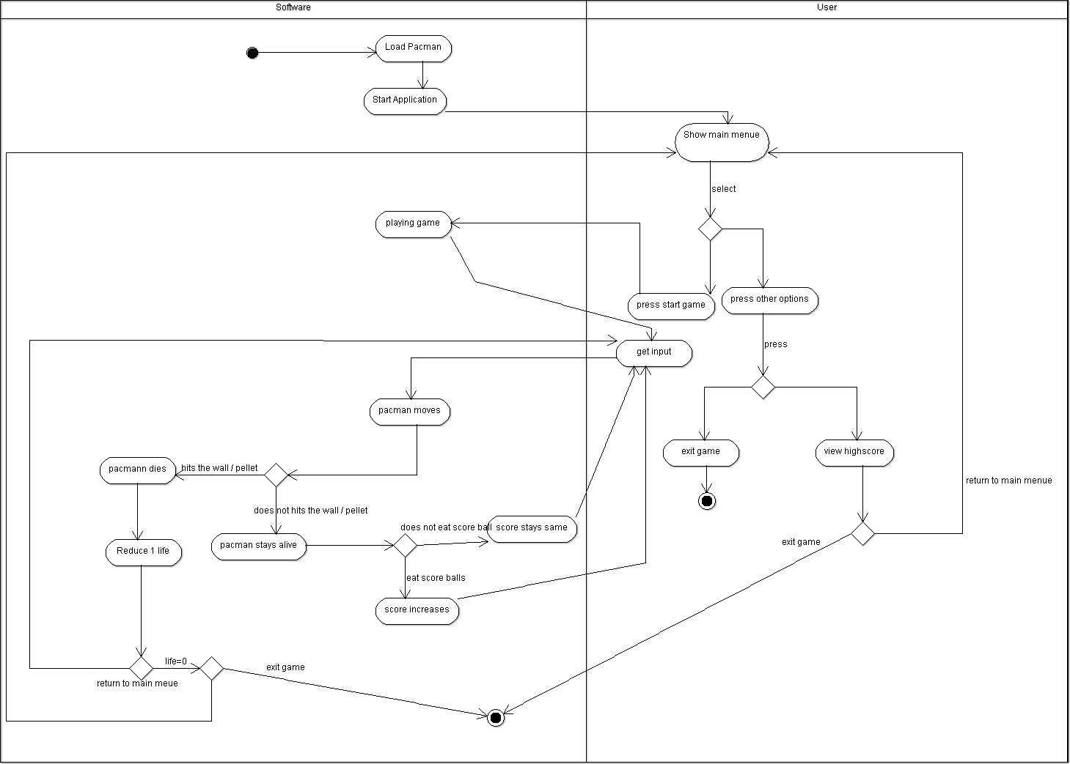

**Sequence Diagram**

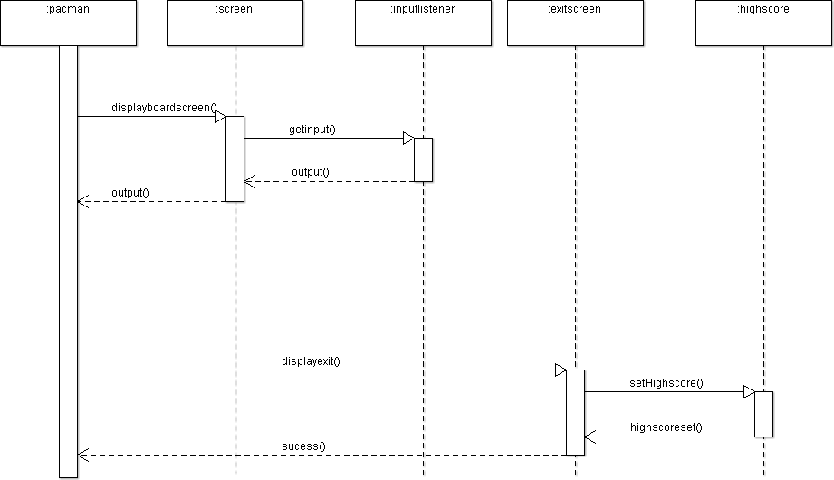

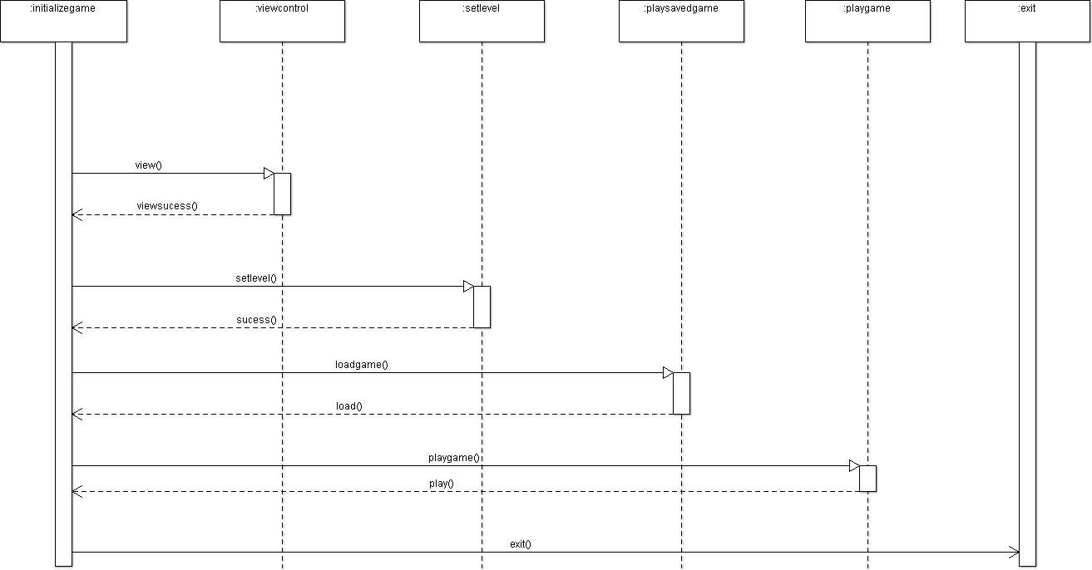

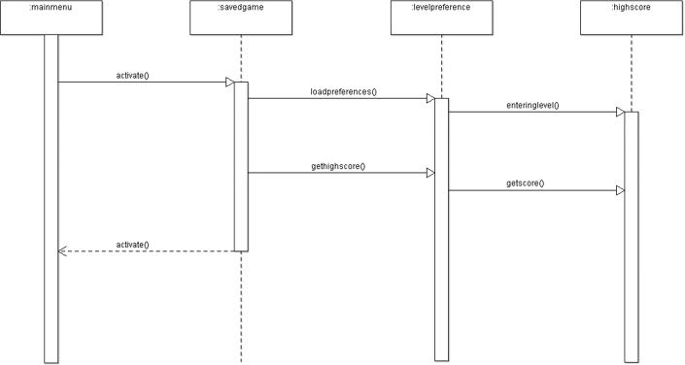

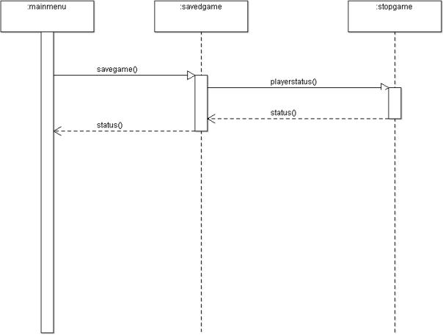

**Deployment Diagram**

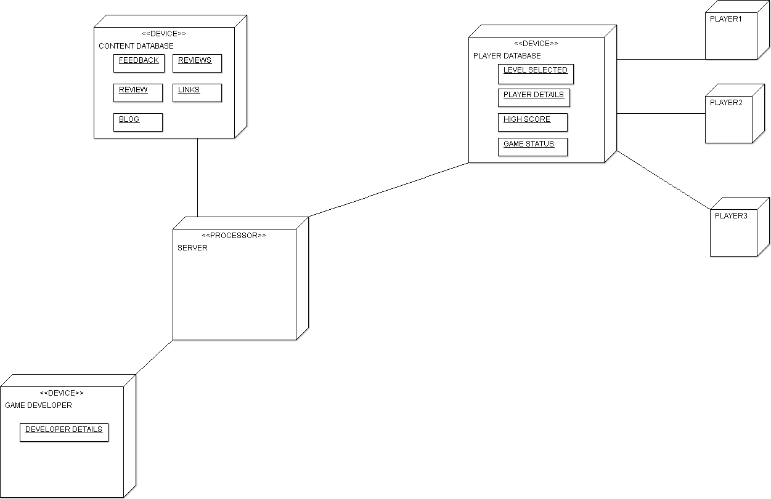

**Component Diagram**

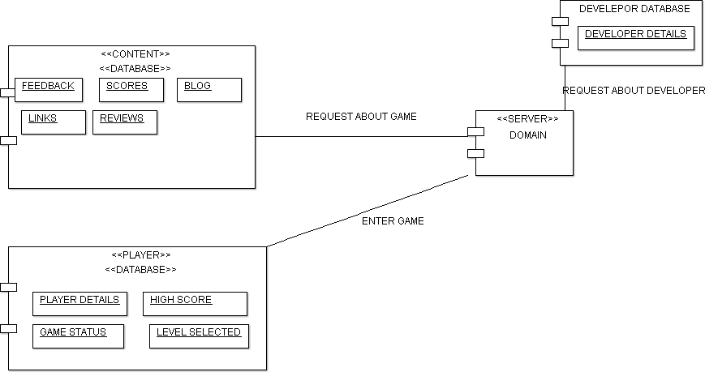

**State Chart Diagram**

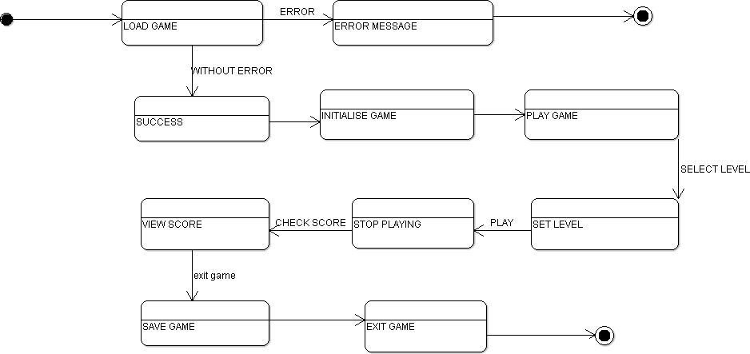

**Collaboration diagram**

Case 1: Working of game from main menu.

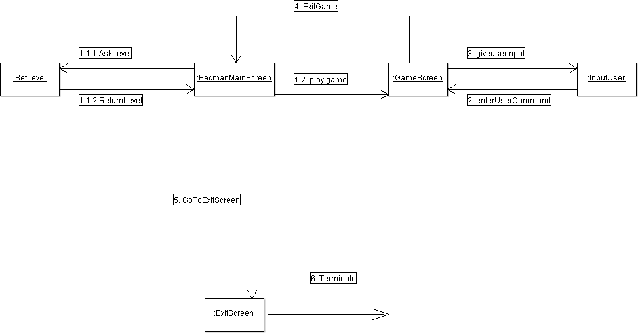

Case 2: When user decides to pause the game, save it and then resume or exit the game or directly wants to exit the game after pausing.

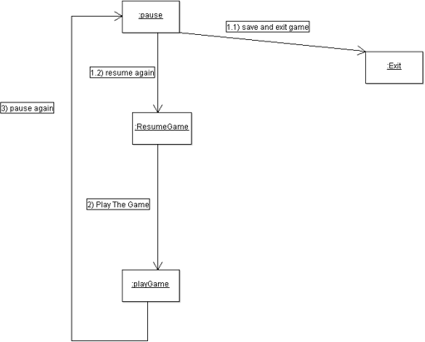

## Object Diagram

